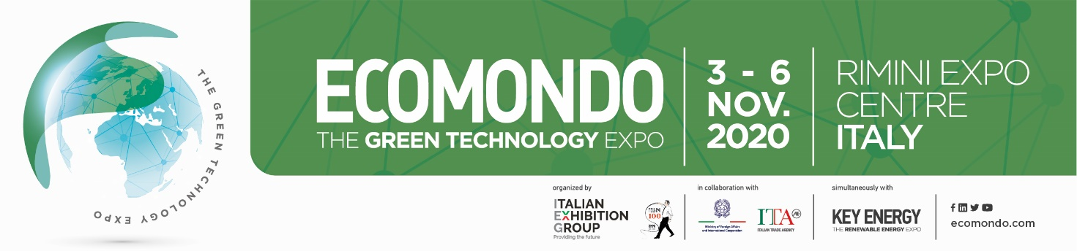

**ECOMONDO / KEYENERGY. The Green Technologies Expo, 24th International Exhibition of Material Recovery, Energy and Sustainable Development, Rimini, Italy. From 3 to 6 November 2020**

**COVID 19: ECOMONDO TRADE SHOW IN ABSOLUTE SAFETY. HERE IS THE ITALIAN EXHIBITION GROUP’S #SAFEBUSINESS PROJECT.** [**www.iegexpo.it/en/safebusiness**](http://www.iegexpo.it/en/safebusiness)

Dear Sir / Madam,

with more of 1160 international exhibitors, 113.000 sq. m. surface, 8600 foreign buyers and 116.000 visitors, ECOMONDO/KEYENERGY, organized by International Exhibition Group, under the patronage of the Italian Ministry of Economic Development, the Italian Ministry of the Environment and Emilia Romagna region, is the most innovative exhibition for what concerns exploitation and recycling of waste and raw materials, energy efficiency, water treatment, green industry, circular economy, solar energy, smart cities and mobility as well as all latest industrial technologies and solutions for ecological production and innovation.

In this framework, Hemispheres Wbd, partner of Ecomondo/Keyenergy for the Arab countries, promotes, in cooperation with the Amman Chamber of Industry, the participation of a Jordanian delegation to ECOMONDO in order to allow Jordanian companies to be acquainted with the latest trends of the green industry and environmental friendly technologies and meet international companies during a **special B2B session**.

**Huge benefits are available to support the participation of Jordanian companies!**

**The B2B session**

To ensure the effective establishment of positive economic relations between Arab and Italian counterparts, a special business meeting session will take place during the exhibition. The meetings will be arranged by means of a special web platform allowing companies to select their counterparts directly on the basis of their specific needs. **The use of the B2B e-platform is mandatory**.

**The following benefits will be offered to the selected entrepreneurs**\*:

* 3 nights bed & breakfast for one person in a four stars hotel (an eventual second person will pay the difference);
* Invitation letter for Visa, if required
* Transfer from and to the airport of arrival and departure (Bologna Airport, BLQ),
* Transfer from/to Hotel and Fair
* Interpreters for the B2B meetings if required (just in case the entrepreneur does not speak English fluently),
* The catalogue of the fair and entry tickets
* Buffet lunch at the exhibition center

Interested companies can register before September 25, 2020 by completing the [**on line registration form**](https://buyers.iegexpo.it/ric20/en/step0?agente=790336) ** or here:** [**https://buyers.iegexpo.it/ric20/en/step0?agente=790336**](https://buyers.iegexpo.it/ric20/en/step0?agente=790336)

*companies that will not attend at least 10 B2B meetings (an attendance sheet to be signed by every Italian company met will be distributed in occasion of the B2B) will not benefit of the payment of the hotel. Likewise, selected companies engage themselves to **arrange business meetings** with exhibitors from 30th September to 27th October 2020 through the web platform. Two days attendance are compulsory.

[Download Ecomondo Brochure here](http://hemisphereswbd.com/wa_files/ECO2020_BROCHURE_AGENTI_ENG_compressed-3_20_281_29.pdf)                             [Download Keyenergy Brochure here](http://hemisphereswbd.com/wa_files/KEY_BROCHURE20_ARAB.pdf)

**Sectors of interest at the 2020 event,** (<http://en.ecomondo.com/>)**:**

* Green Industries
* [Waste management and recycing](http://en.ecomondo.com/areas/expo-areas/waste-management)
* [Biobased industry & bioeconomy](http://en.ecomondo.com/areas/expo-areas/biobased-industry)
* [Sites remediation and risk prevention](http://en.ecomondo.com/areas/expo-areas/waste-collection-and-removal)
* [Water, waste water and sewage](http://en.ecomondo.com/areas/expo-areas/water-waste-and-sewage)
* [Wind](http://en.keyenergy.it/areas/focus/key-wind) energy
* [Solar](http://en.keyenergy.it/areas/focus/key-solar) Energy
* [Energy Storage](http://en.keyenergy.it/areas/focus/key-storage)
* [Energy Efficiency](http://en.keyenergy.it/areas/focus/key-efficiency)
* Smart Cities
* Green Mobility

For further information, participation and support, please contact:

**Mr. Enrico SIEPI**

Hemispheres Wbd

V.le C. Battisti 60, 61121 Pesaro, Italy

Mail: esiepi@hemisphereswbd.com;

[www.hemisphereswbd.com](http://www.hemisphereswbd.com/)

Ph. +39 07211651494

WhatsApp : +393405942281